Assignment 5: Introduction to WAN Technologies & MPLS Basics
Topic: WAN vs. LAN — Key Differences and Use Cases, MPLS Basics, Observing MPLS Routing, Benefits of MPLS
Shreya Panchal

Theory Overview

1. WAN vs. LAN
• LAN (Local Area Network): Connects computers and peripheral devices within a localized geographic area, such as a single office building, university campus, or home. It offers extremely high data transfer rates, low latency, and is typically owned and managed by a single organization using technologies like Ethernet or Wi-Fi.
• WAN (Wide Area Network): Spans across vast geographical boundaries, linking multiple LANs across cities, states, or entire continents. Because it relies on leased public or private telecommunication infrastructure, it typically exhibits higher latency and requires advanced traffic optimization to manage costs and reliability.

2. MPLS Basics (Multiprotocol Label Switching)
Traditional IP routing requires every single router along a path to open an IP packet, inspect the destination IP address, and consult a complex routing table to determine the next hop.
MPLS optimizes this by introducing Label Switching. When a packet enters an MPLS network, the first router inserts a short, fixed-length label into the packet header. Subsequent routers (Label Switch Routers) look only at this short label to make immediate forwarding decisions at the hardware level, bypassing deep routing table lookups entirely. The final router strips the label before delivery. This allows for faster routing, highly efficient Traffic Engineering (TE), and the creation of secure Virtual Private Networks (VPNs) across a shared provider backbone.

Tasks & Answers

Task 1: LAN vs. WAN Comparison & App Examples
Question: Create a comparison table listing at least 3 key differences between WAN and LAN, and give one real-world example of each from apps or services you use daily (for example, IRCTC, Instagram, or Zomato).
Key Feature | LAN (Local Area Network) | WAN (Wide Area Network)
Geographical Scope | Restricted to a small, contained area (e.g., home, single building, lab room). | Interconnects multiple sites across vast distances (cities, countries, or globally).
Ownership / Cost | Private setup; hardware is owned by the user or local institution with low operational costs. | Public or commercial carrier infrastructure; leased lines or subscription links incur high recurring costs.
Speed & Latency | High throughput bandwidth with negligible propagation delay/latency. | Lower bandwidth capacities relative to cost; susceptible to higher propagation delays.
Real-World App Example | Local Network Gaming / Local File Transfer: Playing a multi-player LAN match with a friend sitting in the same room or sending files between devices via local Wi-Fi. | Zomato / Instagram: Running real-time GPS coordinates or loading feeds from remote cloud databases located in completely different cities or countries.

Task 2: Ahmedabad to Bangalore Flipkart Network Diagram
Question: Draw a simple network diagram using any drawing tool (or on paper and upload a photo) that shows how a user in Ahmedabad could connect to a Flipkart data center in Bangalore using a WAN, labeling the LAN and WAN segments clearly.
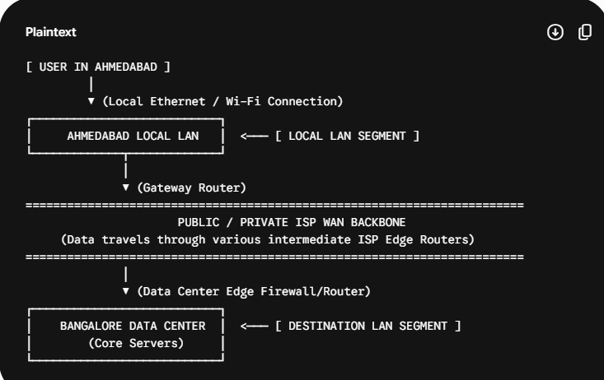

Task 3: Introduction to MPLS Summary
Question: Research and write a short summary (5-7 lines) explaining what MPLS is and how it improves data routing compared to traditional IP routing.
Multiprotocol Label Switching (MPLS) is a high-performance network routing mechanism that forwards data using short routing labels instead of long destination IP network addresses. In traditional IP routing, every router along a path must independently parse Layer 3 headers and execute a slow lookup inside its routing table. MPLS improves this by assigning a dedicated label to packets at the network edge, allowing inner Label Switch Routers (LSRs) to forward traffic instantly via fast hardware lookup. This significantly reduces processing overhead on network devices, lowers latency jitter, and allows service providers to seamlessly dictate exact Quality of Service (QoS) pathways for enterprise customers.

Task 4: Packet Tracer MPLS Observation Behaviors
Question: Observe the pre-configured MPLS network in the provided Packet Tracer or GNS3 file, and note down two routing behaviors that are different from standard IP routing. Hint: Look for how labels are used and how packets move between routers.
• Label Pushing, Swapping, and Popping: In the simulation, when a packet hits an entry router (Ingress LSR), a label header is dynamically pushed onto it. Intermediate routers do not look up destination subnets; instead, they swap the existing label value for a new value based on a pre-defined path matrix. At the exit router (Egress LSR), the label is popped (removed), reverting it back to a standard IP packet. This label action sequence does not happen in regular IP networks.
• Explicit Path Independent of Destination Metric: Unlike standard IP routing, where packets are bound to follow the shortest path determined by destination-based routing tables (e.g., OSPF cost metrics), the simulation shows MPLS traffic traveling along a specific configured tunnel path. Packets follow a pre-engineered trail based entirely on their label matching parameters, even if a shorter native physical routing hop exists.

Task 5: Specific Benefits of MPLS for High-Traffic Platforms
Question: List three specific benefits MPLS offers over traditional routing for companies running high-traffic apps like YouTube or BookMyShow, and briefly explain how each benefit helps in real-world scenarios.

1. Advanced Quality of Service (QoS) and Traffic Prioritization
Real-World Scenario: For an app like YouTube, user traffic consists of critical real-time video stream blocks and non-critical data like comments or view-count logs. MPLS lets the platform categorize traffic using experimental bits in the label header. Video packets get prioritized through high-bandwidth paths to eliminate mid-video buffering, while comment data can safely use standard queues.

2. Avoidance of Core Network Bottlenecks via Traffic Engineering (TE)
Real-World Scenario: During an explosive ticket sale launch on BookMyShow, thousands of users load transaction lines simultaneously, overloading the primary network paths. Traditional routing would keep routing traffic over the shortest overloaded route, causing timeouts. MPLS Traffic Engineering allows network switches to automatically shift excess traffic over alternative underutilized routes, maintaining app availability.

3. Simplified Deployment of Secure Layer 2 & Layer 3 VPNs
Explanation/Scenario: Both platforms operate massive, geographically separate server farms and multi-cloud databases. MPLS allows them to seamlessly bridge isolated cloud arrays and regional payment clearing nodes across a completely secure, private virtual infrastructure tunnel over a provider's grid, keeping billing and backend storage isolated from public internet interference without needing complex multi-layered encryption tunnels.

